**Task 1: Some network terminology.**

1. **Node-** Any device connected to a network, such as computer, printer, or router.
2. **Protocol-** A set of rules and standards that define how devices on a network communicate with each other.data structure
3. **IP Address (Internet Protocol Address)-** A unique numerical identifier assigned to each device on a network, used to identify and communicate with other devices.

Example- 192.168.1.1

1. **MAC Address (Media Access Control Address)-** A hardware identification number that uniquely identifies each device on a network.
2. **Router-** A networking device that connects multiple networks together and forward data packets between them.
3. **Switch-** A networking device that connects devices on a network and forward data packets between them.
4. **Firewall-** A network security system that monitors and controls incoming and outgoing network traffic based on predetermined security rules.
5. **DNS (Domain Name System)-** The phonebook of the internet that translates domain names (like www.google.com) to IP addresses (like 192.0.2.1).
6. **DHCP (Dynamic Host Configuration Protocol)-** A network management protocol used on IP networks whereby a DHCP server automatically assigns an IP address and other network configuration parameters to each device on a network.
7. **VPN (Virtual Private Network)-** A service that allows you to connect to the internet via a server run by a VPN provider. It creates a secure, encrypted tunnel between your computer and the VPN server.
8. **Subnet-** A logically visible subdivision of an IP network. The practice of dividing a network into two or more networks is called subnetting.
9. **Bandwidth-** The maximum rate of data transfer across a given path. It is typically measured in bits per second (bps).
10. **Latency-** The delay before a transfer of data begins following an instruction for its transfer. It is typically measured in milliseconds (ms).
11. **Packet-** A small segment of a large message. Data sent over networks are divided into packets.
12. **Ethernet-** Ethernet is widely used technology for LANs. It defines how data is transmitted over a wired network, using cables to connect devices like computers, switches, and routers within a limited area such as an office or home.
13. **SSID (Service Set Identifier)-** The name of the wireless network, which distinguishes it from other networks in the area.
14. **NAT (Network address translation)-** NAT is a method used in networking to modify network address information in IP packet headers while in transit across a traffic routing device like a router. It allows multiple devices on a local network to share a single public IP address when accessing external networks like the internet.
15. **WAP-** WAP stands for Wireless Access point. It is a device that allows wireless devices to connect to a wired network using Wi-Fi.
16. **Modem-** A modem is a device that modulates and demodulates signals to enable digital data to be transmitted over analog communication channels.

**Task 2: Draw your home network topology and explain how you are accessing the RPS lab environment.**

1. In our home Wi-Fi network, we use the Start topology.

* The router works as the central hub, which is connected to the internet through a modem and provides wireless access via a built-in wireless access point (WAP).
* All devices like computers, smartphones, etc. connected with wires or wirelessly to the router/WAP, forming spokes around the central hub.

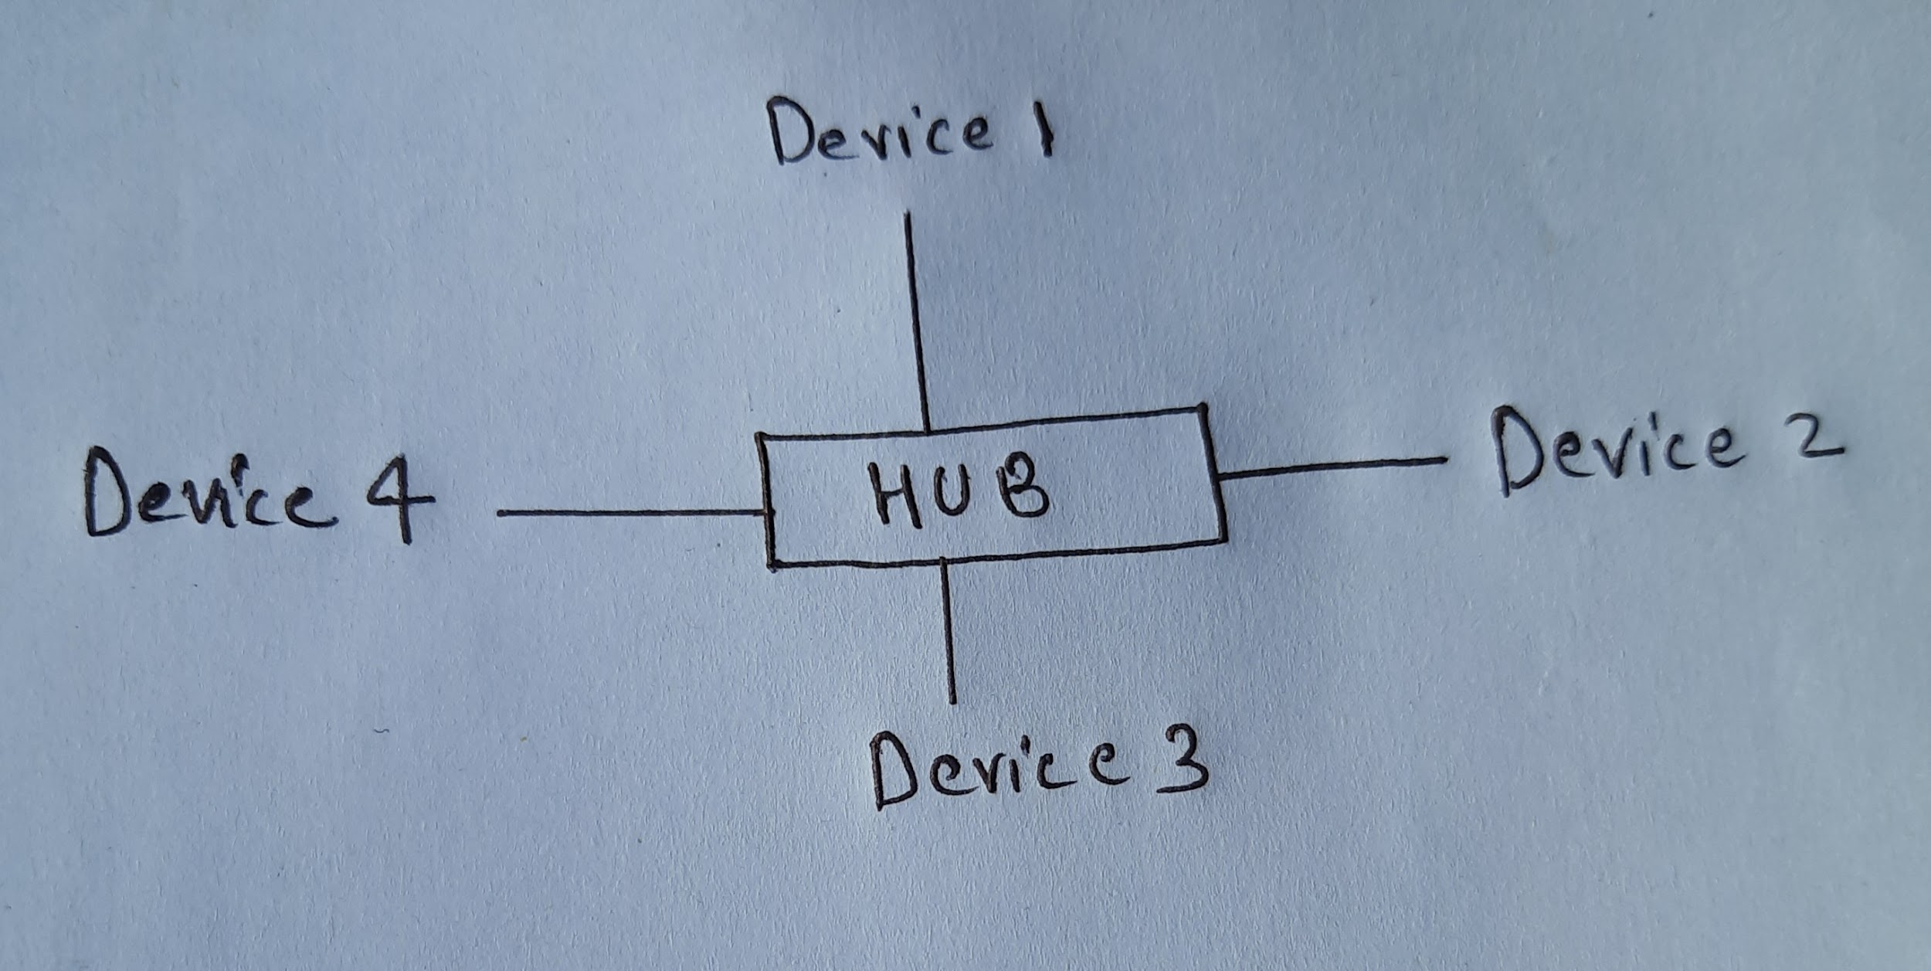

1. **Accessing the RPS lab environment-**

1- Enter the URL to the web browser.

2- The browser uses the DNS to translate domain name to the IP address.

3- Once the browser has the IP address, it sends a request to the web server that hosts the website.

4- The web server receives the request and processes it. This involves retrieving the requested web page and any associated files from storage.

5- The server generates a response.

6- The server sends the response back to the web browser over the internet.

7- The web browser receives the response and interprets it, to render the web page on the screen.

8- Finally, the browser displays the fully rendered web page.